IPO Program Header

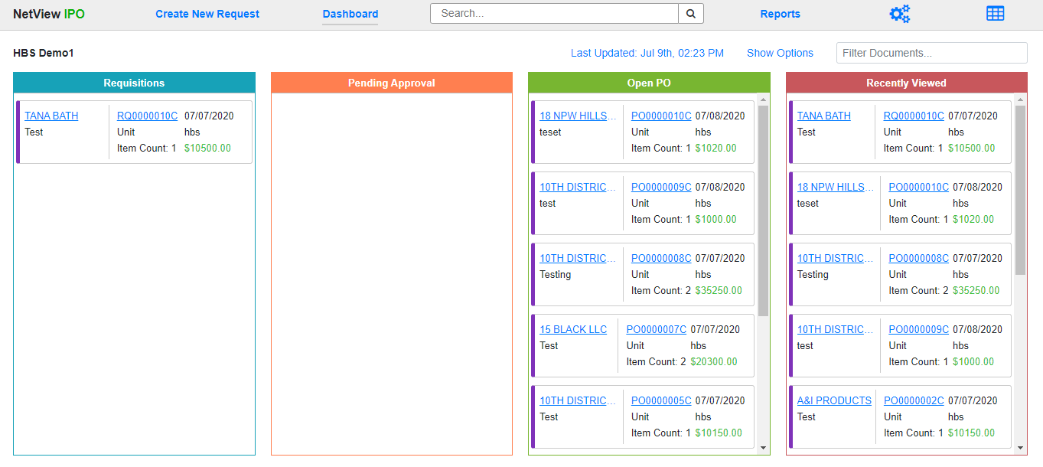

The Program Header in Integrated Purchase Orders (IPO) appears on every screen in the program. It allows you to switch between different program screens and look up documents to work on.

**Create New Request:** Clicking this option allows you create a new requisition to submit as a purchase order. This screen will be explained in more detail when discussing the lifecycles of the different PO types.

**Dashboard:** This option allows you to return to your default Dashboard from any other screen in the program, with the exception of the other Dashboard view.

**Document Search:** Use this field to search for a particular document within the program. Enter all or part of the **document number** and click the **Search** button. **NOTE:** The search will only return documents that you have permission to view with your **IPO role**, i.e. belonging to your location and department.

The following window will open:

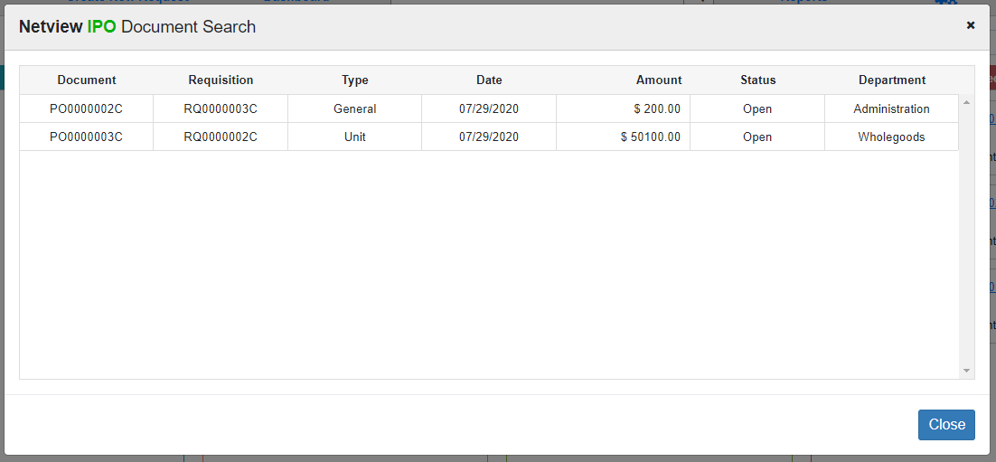

Each search result shows the following:

* Document number
* Requisition number (will be duplicate of document number if document is still a Requisition)
* Document type
* Document creation date
* Document amount
* Document status
* Document department

Click on the document entry to open it.

**Reports:** Click this option to access the **IPO Reports** screen. See “**IPO Repots**” for the screen details.

**Purchase Order Settings:** Click the three-gear icon to open the **Purchase Order Settings** screen. See **“IPO Setup—Purchase Order Settings”** for the screen details.

**Switch to View:** When you have the **Dashboard** open, use this icon to switch between the two available Dashboard views: **Column** and **List**.

Switch to Grid View: The  icon visible from the **Column** view screen is the Switch to List View icon. Click it to switch to the List View.

Switch to Column: The  icon visible from the **List** view screen is the Switch to Column View icon. Click it to switch to Column View.